1 Assignment Question

TOPIC: Python Basics Variable

### 1. Declare two variables, x and y, and assign them integer values. Swap the values of these variables without using any temporary variable.

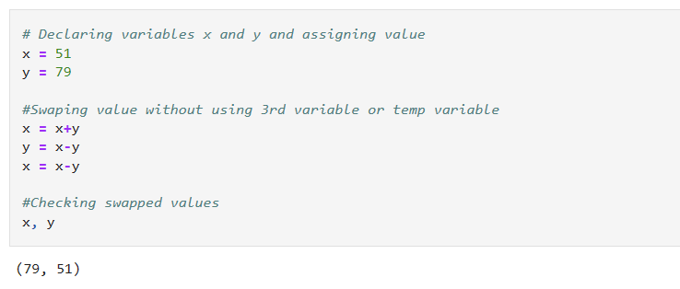

### 2. Create a program that calculates the area of a rectangle. Take the length and width as inputs from the user and store them in variables. Calculate and display the area.

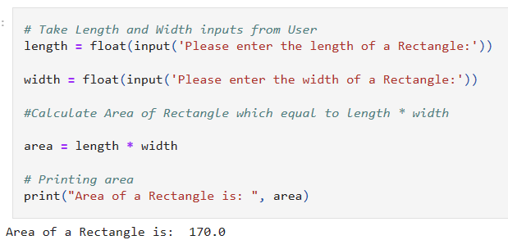

### 3. Write a Python program that converts temperatures from Celsius to Fahrenheit. Take the temperature in Celsius as input, store it in a variable, convert it to Fahrenheit, and display the result.

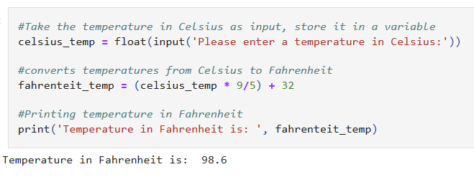

## **String based questions**

### 1. Write a Python program that takes a string as input and prints the length of the string.

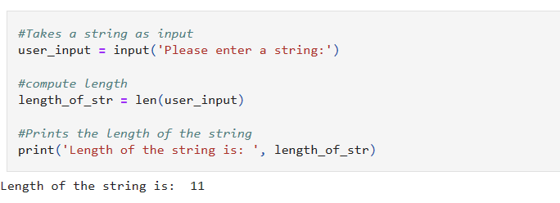

### 2. Create a program that takes a sentence from the user and counts the number of vowels (a, e, i, o, u) in the string.

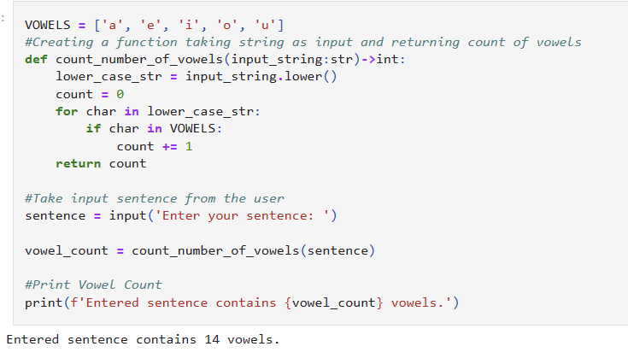

### 3. Given a string, reverse the order of characters using string slicing and print the reversed string.

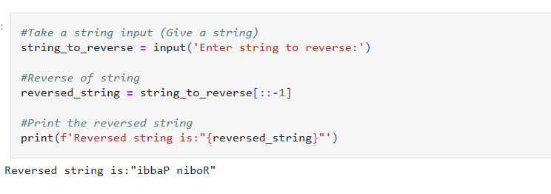

### 4. Write a program that takes a string as input and checks if it is a palindrome (reads the same forwards and backwards).

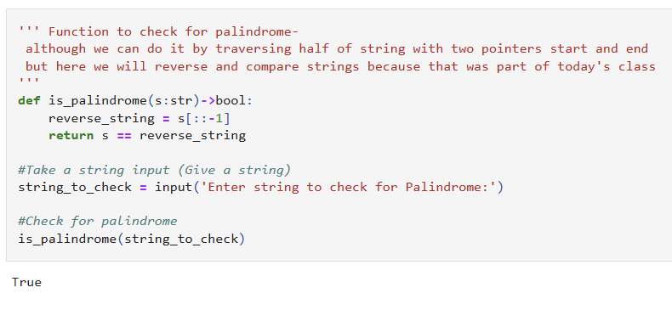

### 5. Create a program that takes a string as input and removes all the spaces from it. Print the modified string without spaces.

